Mapping Homework Name _______________________________ Period _______

Section 1: Identifying Types of Maps Practice Section Due Date ______________

For each of the following statements…
1. Decide which type of map (Political, Physical, or Thematic) would be the best choice for locating the given information.
2. Explain why you made that choice.

1. The Continents of the World:
Map Type ______________________
Why? ____________________________________________________________________
2. The biggest cities in China:
Map Type _____________________
Why? ____________________________________________________________________
3. The lakes that surround Michigan:
Map Type ______________________
Why? ____________________________________________________________________
4. London's Subway System:
Map Type ______________________
Why? ____________________________________________________________________
5. The routes of last year's hurricanes to hit The Untied States:
Map Type ______________________
Why? ____________________________________________________________________
6. The capital cities of South America:
Map Type ______________________
Why?_____________________________________________________________________
7. A map of the rivers leading into the Mississippi River Basin:
Map Type ______________________
Why? ____________________________________________________________________
8. A map showing the world's active volcanoes:
Map Type ______________________
Why? ____________________________________________________________________
9. The mountain peaks of the Rocky Mountains:
Map Type ______________________
Why? ____________________________________________________________________
10. The cities surrounding the Denver Metro Area:
Map Type ______________________
Why?_____________________________________________________________________

Section 3: Latitude and Longitude Practice Section Due Date: ________________

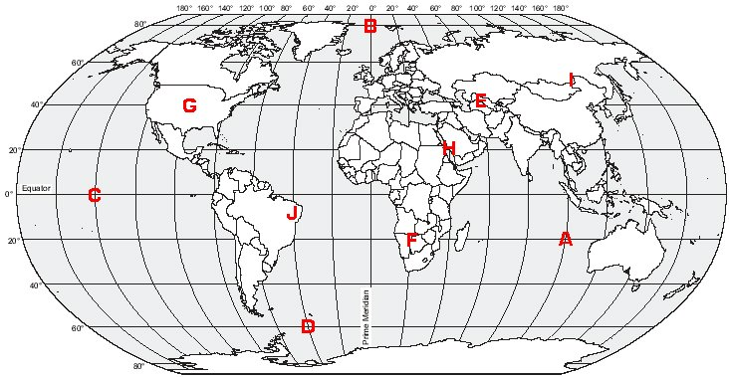
Directions: Write the latitude and longitude coordinates of the letters on the above map in the spaces below.

A. ______ ˚ _______ Latitude and ______ ˚ _______ Longitude

B. ______ ˚ _______ Latitude and ______ ˚ _______ Longitude

C. ______ ˚ _______ Latitude and ______ ˚ _______ Longitude

D. ______ ˚ _______ Latitude and ______ ˚ _______ Longitude

E. ______ ˚ _______ Latitude and ______ ˚ _______ Longitude

F. ______ ˚ _______ Latitude and ______ ˚ _______ Longitude

G. ______ ˚ _______ Latitude and ______ ˚ _______ Longitude

H. ______ ˚ _______ Latitude and ______ ˚ _______ Longitude

I. ______ ˚ _______ Latitude and ______ ˚ _______ Longitude

J. ______ ˚ _______ Latitude and ______ ˚ _______ Longitude

Section 2: In your Own Words Section Due Date __________________

Directions: Define the following terms in your own words and try to apply them to the given scenarios below.

1. a. Define what a Compass Rose is. Draw a Compass Rose below your definition.

b. Define Relative Location:

c. Define Absolute Location:

2. Describe where you live (your house or Brighton) using 2 complete sentences. The first sentence use Relative Location to describe where you live. In the second sentence use Absolute Location to describe where you live?

3. You are the tour guide at “OTMS Back to School Night.” A parent asks you how to get from Mr. Rick’s classroom to the Technology classroom. Give the parent directions to the classroom using the Compass Rose and Relative Location.

